**VAISHNAVI E 231901059**

**EX.NO:6A**

**DATE:22.02.2025**

**FIRST COME FIRST SERVE**

**Aim:** To implement First-come First- serve (FCFS) scheduling technique

**Algorithm:**

1. Get the number of processes from the user.
2. Read the process name and burst time.
3. Calculate the total process time.
4. Calculate the total waiting time and total turnaround time for each process
5. Display the process name & burst time for each process.
6. Display the total waiting time, average waiting time, turnaround time

**Program Code:**

#include <stdio.h> int main() {

int n;

// Step 1: Get the number of processes

printf("Enter the number of processes: ");

scanf("%d", &n);

int burst_time[n], waiting_time[n], turnaround_time[n]; // Step 2: Read the burst time for each process printf("Enter the burst time of the processes: "); for (int i = 0; i < n; i++) {

scanf("%d", &burst_time[i]);

}

// Initialize waiting time and turnaround time to 0

waiting_time[0] = 0;

turnaround_time[0] = burst_time[0];

// Step 3: Calculate waiting time and turnaround time for each process int total_waiting_time = 0; int total_turnaround_time = 0;

// Calculate waiting time for each process for (int i = 1; i < n; i++) { waiting_time[i] = burst_time[i - 1] + waiting_time[i - 1];

}

// Calculate turnaround time for each process

for (int i = 0; i < n; i++) { turnaround_time[i] = burst_time[i] + waiting_time[i];

}

// Step 4: Display the results

printf("\nProcess\tBurst Time\tWaiting Time\tTurnaround Time\n"); for (int i = 0; i < n; i++) { printf("%d\t%d\t\t%d\t\t%d\n", i, burst_time[i], waiting_time[i], turnaround_time[i]); total_waiting_time += waiting_time[i];

total_turnaround_time += turnaround_time[i];

}

// Step 5: Calculate and display average waiting time and turnaround time float avg_waiting_time = (float)total_waiting_time / n; float avg_turnaround_time = (float)total_turnaround_time / n;

printf("\nAverage Waiting Time: %.2f\n", avg_waiting_time);

printf("Average Turnaround Time: %.2f\n", avg_turnaround_time); return 0;

}

**Output:**

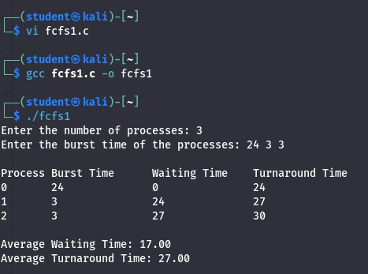

**Result:**

Hence, FCFS CPU scheduling and total waiting time, average waiting time, turnaround time has been calculated.